NORTH DAKOTA DEPARTMENT OF PUBLIC INSTRUCTION
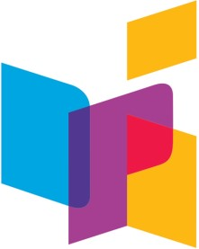
KIRSTEN BAESLER, STATE SUPERINTENDENT 600 EAST BOULEVARD AVENUE, DEPT. 201, BISMARCK, ND 58505
The
ND ExcELLing Educator
North Dakota ELL Newsletter |  |  |  | February-March 2017
 | ACCESS 2.0 |  | Professional Development
 | •  •  •  • | The ACCESS 2.0 test window has now closed. Districts should have all test material packed and shipped to DRC.  ACCESS 2.0 Scoring Appeals and Data Corrections  1. First scoring appeals and data correction window  - July 14, 2017 – Last date to request an appeal or data correction  - August 30, 2017 – Reporting for the first appeals and data correction window  1. Second and final appeals and data correction window  - September 22, 2017 – Last date to request an appeal or data correction  - October 30, 2017 – Reporting for second and final appeals and data correction window  Updated Score Report Webinar for Families of ELs A series of three webinars for parents and families has been updated for 2017. The first webinar, “My child is an English language learner. How do I know if my child is making progress?” is now available, two additional webinars are coming later this month.  New Tutorial: Accessing Score Reports: A new training tutorial entitled "Accessing Score Reports" has been posted to the Afterward page of the Online and Paper- | •  •  •  •  •  • |  | Building Bridges: Strengthening Partnerships for Stronger Foundations  March 28-29, 2017 Holiday Inn Fargo, ND  Picturing Writing: Fostering Literacy Through Art June 20-23, 2017 Bismarck, ND  Information or Registration  Image-Making: Within the Writing Process June 26-28, 2017 Bismarck, ND  Information or Registration  CLIMBS: Build Capacity, Increase Collaboration,  Improve EL Education 2017 Institute June 27-30, 2017 Madison, WI  Information or Registration  WIDA Academy: Scaffolding to Support Language  Development  June 20-22, 2017 Nashville, TN  Information or Registration  WIDA Academy: Formative Language Assessment  September 26-28, 2017 Bloomington, MN  Information or Registration
based ACCESS for ELLs 2.0 training course. This tutorial provides instructions on how to access score reports in WIDA AMS and contains a brief overview of

• | the types of reports available.  2017 ACCESS for ELLs 2.0 Score Changes: As a result of the standards setting process in the summer of 2016, the bar has been raised for language proficiency. You may see your students’ score appear to go down. WIDA has created a flyer for LEAS and a webpage of information to help LEAs understand and assist in the parent and student understanding. | Every Student Succeeds Act (ESSA)  The ND ESSA Committee has completed the draft of the ND ESSA plan. You can review the DRAFT of the North Dakota ESSA Plan on the NDDPI website.
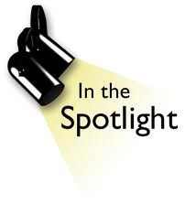
North Dakota has many outstanding teachers and the area of instruction for English learners (ELs) is no different. Meet Leah Juelke, an EL teacher in Fargo who has a great project her ELs have been working on.

Fargo South High School

Narrative Short Stories

They are partnering with Green Voices to develop a
Lodee Arnold book with a teacher’s guide to help teach diversity and
Assistant Director
tolerance. The book launch will be March 28th in
Office of Indian/Multicultural Education Phone: (701) 328-1876
Fargo. They also have video transcripts available for
600 East Boulevard Ave. Dept. 201 Fax: (701) 328-0203
viewing. Bismarck, ND 58505-0440 Email: laarnold@nd.gov

